

THE COPPERBELT UNIVERSITY  
SCHOOL OF INFORMATION COMMUNICATION TECHNOLOGY

Smart Bin: Reward-Based Waste Sorting  
System

Project Report  
  
**Done By**

Name: Bulaya Mwanaute

SIN: 20150307

Programme: Computer Engineering

**Supervised By**

Professor J. Mbale

# Abstract

The project presents the design and implementation of a smart, AI-powered waste sorting bin aimed at improving waste management practices through automation. Improper waste segregation at the disposal stage contributes significantly to the growing challenges of landfill overflow, poor recycling efficiency, and environmental pollution. This project leverages image classification and servo-controlled hardware mechanisms to detect and sort waste items like plastic, metal, and glass into appropriate compartments. Additionally, it incorporates an incentive mechanism using a coin dispenser to encourage proper recycling. The system consists of a microcontroller, a camera module, ultrasonic sensor, and servo motors that control various mechanical components. The innovation lies in applying embedded AI on a small scale, allowing deployment in homes, schools, or public spaces without the need for massive infrastructure. The project combines concepts from computer engineering, machine learning, and sustainable design, offering a scalable and educational solution to one of today’s most pressing environmental issues.

# Declaration

# Dedications

I dedicate this project to my family and friends for their unwavering support and encouragement throughout my academic journey. To all those who believe in the power of innovation for environmental sustainability — this work is for you.

# Acknowledgements

I would like to express my sincere gratitude to my supervisor(s), faculty, and peers whose guidance and encouragement have supported me throughout the development of this project. I also acknowledge the work of researchers, developers, and contributors whose existing publications, datasets, and code samples have served as a foundation and inspiration for some aspects of this system. Wherever applicable, due credit has been given through citations or in-text references. I remain grateful for the resources that made this research possible.

# Table of Contents

Abstract 1

Declaration 2

Dedications 3

Acknowledgements 4

Table of Contents 5

List of Figures 7

List of Tables 8

Chapter 1: Introduction 1

1.1. Introduction 1

1.2. Background of Study 1

1.3. Problem Statement 1

1.4. Objectives 2

1.5. Hypothesis and Assumptions 2

1.6. Purpose, Scope and Applicability 2

1.7 Organisation of the Project 3

Chapter 2: Literature Review 4

2.1. Introduction 4

2.2 Related Work 4

2.2.1 TrashBot by CleanRobotics 5

2.2.2 Bin-e Smart Waste Bin 5

2.3. References 8

Chapter 3: Research Methodology 10

3.1. Introduction 10

3.2. Methodology 10

Phases of Implementation: 10

System Development Approach 11

Tools and Technologies 11

3.3 Information Gathering And Analysis 12

Literature Review and Background Research 12

Survey on Local Waste Disposal Behavior 12

Site Observation and Waste Profiling 13

Requirements Derivation and Stakeholder Needs 13

3.4. Requirements Specification 14

3.4.1 User Requirements 14

3.4.2 System Requirements 14

Functional Requirements 14

Non-Functional Requirements 14

3.5. System Analysis 15

3.5.1 Use Case Diagram 16

3.5.2 System Flowchart 17

3.5.3 System Components and Interactions 18

3.6. Conclusion 18

Chapter 4: System Design 19

4.1. Introduction 19

4.2. System Analysis 19

4.3. Context Model 21

4.4. Design Methods 22

4.4.1. Architectural Design 22

Hardware Architecture 22

Software Architecture 23

System Integration 23

4.4.2. Detailed Design 24

4.4.3. Physical Design 28

a) User Interaction 28

b) Mechanical Layout 28

c) Data and Control Flow 28

d) Output and Feedback 28

e) 3D Design 29

4.5. Conclusion 29

Chapter 5: Implementation 30

5.1 Introduction 30

5.2 System Implementation 30

5.2.1 Hardware Implementation 30

5.2.2 Software Implementation 30

5.2.3 Algorithm and Logic 31

5.3 Coding 31

5.4 Results 32

5.5 Conclusion 32

Chapter 6: Testing and Results 33

6.1 Introduction 33

6.2 Test Plan 33

6.3 Test Environment 33

6.4 Test Cases and Results 33

6.4.1 Unit Testing 33

6.4.2 Integration Testing 34

6.4.3 System Testing 34

6.4.4 User Testing 34

6.5 Analysis 34

6.6 Conclusion 35

# List of Figures

Figure 1: TrashBot. Accessed May 2025. 4

Figure 2: Bin-e smart waste bin in public location. Accessed May 2025. 4

Figure 3: Oscar Sort assistant guiding waste disposal. Accessed May 2025. 5

Figure 4: DeepWaste app detecting recyclable packaging. Accessed May 2025. 6

Figure 5: AMP Robotics sorting system in an industrial setting. Accessed May 2025. 7

Figure 6: Smart Bin System use case diagram 15

Figure 7: Smart Bin flow chart diagram  16

Figure 8: Smart Bin context diagram 20

Figure 9: Smart Bin Architectural Design Diagram 21

Figure 10: Smart Bin Data Flow Diagram 23

# List of Tables

# Chapter 1: Introduction

## 1.1. Introduction

In recent years, waste generation has increased due to rapid industrialization, urbanization, and changes in consumer behavior. The improper disposal of waste has led to severe environmental problems, including pollution, depletion of natural resources, and increased carbon emissions. While many countries have implemented recycling programs, these efforts are often undermined by **inefficient sorting** at the disposal stage. The reliance on **human labor** for waste segregation is not only costly and inefficient but also poses health risks to workers handling hazardous materials.

With advancements in **machine learning, image recognition, and IoT-based automation**, AI-driven solutions can address these challenges by introducing **smart waste sorting systems**. These systems leverage **computer vision and AI models** to identify and classify waste into categories such as plastics, metals, paper, and organic waste. By automating waste sorting, this project aims to reduce human effort, improve recycling rates, and contribute to a more sustainable future.

The **Smart Bin: AI-Driven Waste Sorting** project proposes the development of an intelligent waste management system that uses **computer vision and sensor-based detection** to automatically classify and sort waste into designated compartments. The system will be designed to be user-friendly, cost-effective, and adaptable for both household and industrial use.

## 1.2. Background of Study

Waste management is one of the most pressing environmental challenges of the modern era. As global populations grow and urbanization accelerates, the volume of waste generated continues to increase at an alarming rate. Traditional waste disposal methods, such as landfilling and incineration, contribute significantly to environmental degradation, including soil contamination, air pollution, and greenhouse gas emissions.

Recycling is a widely recognized solution to mitigate these impacts, yet its effectiveness is often hindered by improper waste segregation at the source. Many people dispose of waste incorrectly due to a lack of awareness, leading to recyclable materials ending up in landfills. Manual waste sorting is labor-intensive, inefficient, and often hazardous, exposing workers to health risks.

The advent of **artificial intelligence (AI), computer vision, and Internet of Things (IoT) technologies** presents an opportunity to revolutionize waste management. Smart waste sorting systems powered by AI can significantly enhance the efficiency and accuracy of waste classification, ensuring that recyclable materials are properly identified and redirected to the appropriate recycling channels. This project proposes the development of an **AI-driven smart bin** capable of automatically sorting waste based on material type, thus promoting sustainable waste management practices and reducing landfill waste.

## 1.3. Problem Statement

Waste mismanagement remains a **global environmental and economic issue**, contributing to excessive landfill waste and pollution. A key challenge in recycling is the **incorrect sorting of materials**, which contaminates recyclables and reduces their efficiency. Current waste management solutions **lack automation and rely on human intervention**, making them prone to errors and inefficiencies.

To address this issue, a **Smart Bin with AI-driven waste classification** will be developed to **automatically identify and separate waste materials**. This will **improve recycling efficiency, reduce human sorting efforts, and encourage proper waste disposal behaviors**.

## 1.4. Objectives

To design and develop a **Smart Bin that automatically identifies, classifies, and sorts waste** using **computer vision and IoT technology**, enhancing **waste recycling efficiency and reducing landfill waste**.

****Specific Objectives****

1. **Develop an AI-based waste classification system** capable of identifying **plastic, metal, and organic waste**.
2. **Implement a motorized sorting mechanism** that directs waste into the appropriate compartment.
3. **Develop an IoT-based system** for real-time monitoring of waste levels and collection schedules.
4. **Test and evaluate** the system’s sorting accuracy, efficiency, and effectiveness in a real-world setting.

## 1.5. Hypothesis and Assumptions

* The AI model can reliably classify and sort waste materials with high accuracy.
* Users will comply with using the system correctly, reducing contamination in recyclable materials.
* The automated sorting mechanism will be efficient and reliable, reducing manual intervention in waste management.
* The system’s IoT functionality will improve waste collection efficiency and minimize overflow issues.

## 1.6. Purpose, Scope and Applicability

This study focuses on the **design, development, and evaluation** of an **AI-driven smart bin** capable of automatically sorting waste into different categories based on material composition. The system will utilize **computer vision, machine learning, and sensor-based detection** to classify and separate waste into recyclable and non-recyclable compartments. The primary goal is to enhance waste management efficiency, promote recycling, and reduce human intervention in waste sorting.

The scope of the study includes the following key areas:

1. **Technical Feasibility** – Developing and testing a prototype smart bin equipped with AI-powered waste classification, image recognition, and automated sorting mechanisms.
2. **User Adoption & Behavior Analysis** – Investigating how users interact with the smart bin and identifying factors influencing their willingness to use AI-driven waste sorting solutions.
3. **System Integration & Scalability** – Exploring how the smart bin could be integrated into **municipal waste management systems, recycling plants, and commercial facilities** to enhance large-scale waste sorting.
4. **Material Recognition Limitations** – Identifying potential challenges in waste identification, such as **mixed-material waste, contaminated recyclables, and AI misclassification**, and evaluating strategies to improve sorting accuracy.
5. **Power Consumption & Sustainability** – Assessing the energy requirements of the system and exploring sustainable power sources such as **solar panels or low-energy microcontrollers**.
6. **Data Privacy & Ethical Considerations** – Evaluating the ethical implications of using AI in waste management, including **data privacy concerns** if the system collects and processes user-related waste data.
7. **Economic Feasibility** – Analyzing the cost-effectiveness of the smart bin prototype and its potential for large-scale production, including **manufacturing costs, maintenance, and long-term benefits**.

The study will primarily focus on **small-scale and controlled environments**, such as **universities, offices, or residential communities**, to test the effectiveness of the prototype. However, the findings will also explore its applicability in **industrial and municipal waste management**.

## 1.7 Organisation of the Project

This project report is structured into five main chapters, each focusing on a distinct aspect of the research and implementation process:

* Chapter One: Introduction  
  Provides an overview of the project, including the background, problem statement, objectives, justification, and scope. It also outlines the structure of the entire report.
* Chapter Two: Literature Review  
  Reviews existing work, theories, and technologies related to waste management, smart bin systems, and AI-based classification. It highlights the research gap and situates this project within the broader context of related innovations.
* Chapter Three: Research Methodology  
  Describes the approach used to carry out the study, including the system development methodology, data sources, hardware and software requirements, and model training strategy.
* Chapter Four: System Design and Implementation  
  Explains the technical design of the system, including the architecture, hardware integration, software development, and how the system achieves the stated objectives.
* Chapter Five: Testing, Results, and Conclusion  
  Presents the results of the implementation and testing process, evaluates system performance, and discusses challenges encountered. It concludes with recommendations for future improvements and applications.

# Chapter 2: Literature Review

## 2.1. Introduction

This chapter presents a comprehensive review of existing knowledge, research findings, systems, and technologies relevant to the development of an AI-driven smart bin for waste classification and reward-based recycling. The aim of this review is to understand the origin of the waste management problem, examine existing solutions, assess their strengths and limitations, and identify research gaps that justify the need for the current project.

The problem of poor waste management, particularly in developing regions, stems from the lack of effective infrastructure for waste segregation at the source. The majority of waste ends up in mixed forms, which hinders recycling efforts and leads to increased environmental harm. It is already known that automation in waste sorting can significantly improve recycling efficiency and reduce human exposure to hazardous materials. However, most existing methods are either too expensive, lack adaptability for small-scale deployment, or do not incentivize proper disposal behavior at the individual level.

To address these shortcomings, several solutions have been proposed and implemented. These include manual sorting, industrial sorting plants using magnetic and optical sensors, and early versions of smart bins that rely on basic classification techniques. Recent advancements in computer vision and artificial intelligence have introduced new possibilities for real-time waste detection and classification. Models like YOLO and datasets like TrashNet and TACO have enabled researchers to automate waste identification based on images. However, these solutions typically group waste into generic categories such as “plastic,” “metal,” or “glass,” and do not consider the potential for object-level specificity or behavioral reward systems.

This literature review is structured as follows:

* Section 2.2 examines previous implementations of smart bins and automated sorting infrastructure.
* Section 2.3 presents related work that explores existing research on AI-based waste classification systems.
* Section 2.4 compiles the sources cited in the review.
* Section 2.5 summarizes the lessons learned from reviewing current technologies.
* Section 2.6 offers a critical evaluation of the reviewed literature.
* Section 2.7 concludes the chapter by identifying research gaps and justifying the objectives of the proposed project.

## 2.2 Related Work

This section describes real-world applications and systems that are similar in function or concept to the AI-powered smart bin proposed in this project. These systems typically aim to automate the process of waste classification and improve recycling efficiency through the use of artificial intelligence, robotics, and smart technologies. Their features, platforms, and limitations provide valuable insights that help define the strengths and innovations of the proposed system.

### **2.2.1 TrashBot by CleanRobotics**

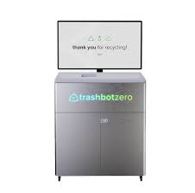

Figure 1: TrashBot. Accessed May 2025.

**Source**: https://cleanrobotics.com/trashbot

**Platform**: Standalone AI-powered smart bin

**Description**: TrashBot automatically sorts waste into recyclables, compostables, and landfill categories at the point of disposal. Using computer vision and machine learning, the system identifies materials in real time and improves accuracy through continuous learning.

**Target Users**: Airports, malls, universities, and high-traffic public areas.

**Relevance**: TrashBot shares core functionality with the proposed system — such as AI-driven classification — but does not incorporate item-specific detection or a reward system for proper recycling behavior.

### **2.2.2 Bin-e Smart Waste Bin**

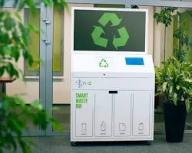

Figure 2: Bin-e smart waste bin in public location. Accessed May 2025.

**Source**: [https://www.bine.world](https://www.bine.world/)

**Platform**: Indoor smart bin with automatic classification

**Description**: Bin-e uses sensors and AI to recognize, sort, and compress recyclable materials such as plastic, glass, and paper. It offers real-time data reporting and alerts for optimized waste management.

**Target Users**: Offices, educational buildings, medical facilities.

**Relevance**: While Bin-e excels in automation and real-time reporting, it lacks integration with behavior-shaping elements like user feedback or incentive systems, which are central to this project.

**2.2.3 Oscar Sort by Intuitive AI**

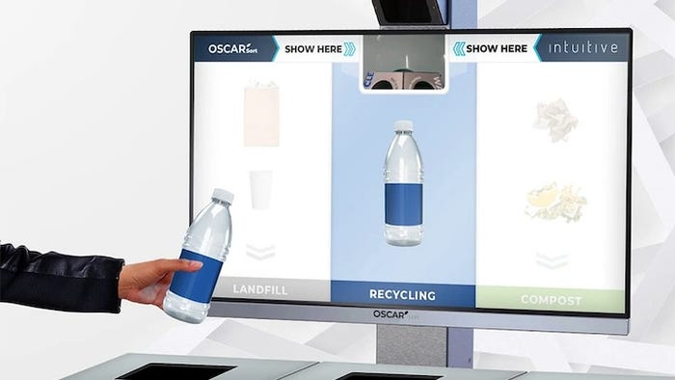

Figure 3: Oscar Sort assistant guiding waste disposal. Accessed May 2025.

**Source**: https://intuitiveai.ca/oscar-sort

**Platform**: AI-powered disposal assistant

**Description**: Oscar Sort scans waste in front of a user and provides real-time instructions on proper disposal via a digital display. It relies on AI object recognition and educates users while preventing incorrect disposal.

**Target Users**: Campuses, corporate sites, retail centers.

**Relevance**: Unlike fully automated systems, Oscar Sort enhances human decision-making rather than replacing it. This contrasts with the proposed system, which automates both classification and sorting but could incorporate similar real-time feedback.

**2.2.4 DeepWaste Mobile App**

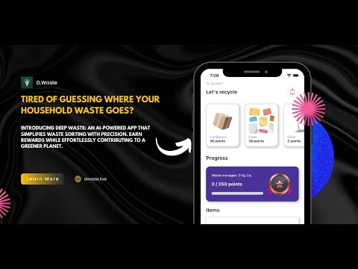

Figure 4: DeepWaste app detecting recyclable packaging. Accessed May 2025.

**Source**: [*https://github.com/sumn2u/deep-waste-app?tab=readme-ov-file*](https://github.com/sumn2u/deep-waste-app?tab=readme-ov-file)

**Platform**: Mobile application for personal waste classification

**Description**: DeepWaste employs a deep learning model deployed on mobile devices to help users categorize waste into trash, recycling, and compost. Users take a photo, and the app classifies the item with high accuracy.

**Target Users**: Individuals, households, educational users.

**Relevance**: DeepWaste demonstrates lightweight, mobile-compatible AI use — supporting the idea that classification systems can run on lower-power devices, similar to the microcontroller-driven bin in this project.

**2.2.5 AMP Robotics**

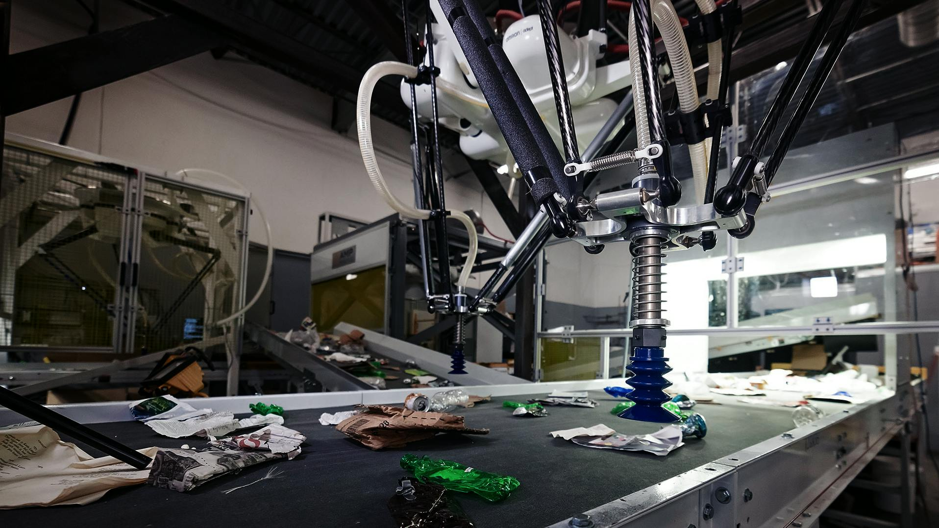

Figure 5: AMP Robotics sorting system in an industrial setting. Accessed May 2025.

**Source**: [https://ampsortation.com](https://ampsortation.com/)

**Platform**: AI-powered robotic sorting for industrial recycling plants

**Description**: AMP Robotics builds intelligent recycling robots that use AI to recognize and separate recyclable materials by type, color, shape, and even brand. The systems are deployed in large-scale material recovery facilities (MRFs).

**Target Users**: Municipal waste processors, industrial recyclers.

**Relevance**: While operating at a vastly larger scale, AMP's approach to brand-level recognition and robotic automation mirrors the ambitions of this project — adapted for a compact, affordable unit intended for everyday users.

## 2.3. References

* ResearchGate. (2023). *Literature mapping of waste sorting and recycling behavior research: a visual analysis using CiteSpace*. (Referencing Nelles et al., 2016 and Tai et al., 2023). Available at: <https://www.researchgate.net/publication/370519803_Literature_mapping_of_waste_sorting_and_recycling_behavior_research_a_visual_analysis_using_CiteSpace>
* ResearchGate. (2025). *Determinants of household-level solid waste sorting practice the case of Bure town, North-western Ethiopia*. Available at: <https://www.researchgate.net/publication/390498033_Determinants_of_household-level_solid_waste_sorting_practice_the_case_of_Bure_town_North-western_Ethiopia>
* SBN (Simple But Needed). (2024). *What are the challenges faced in waste management for small businesses?* Available at: <https://sbnsoftware.com/blog/what-are-the-challenges-faced-in-waste-management-for-small-businesses/>
* SBN (Simple But Needed). (2025). *What are the emerging trends in waste management practices?* Available at: <https://sbnsoftware.com/blog/what-are-the-emerging-trends-in-waste-management-practices/>
* Waste Technology. (n.d.). *5 Top Household Municipal Solid Waste Sorting Equipment Technologies*. Available at: <https://waste-technology.co.uk/5-top-household-municipal-solid-waste-sorting-equipment-technologies.html>
* BasicAI. (n.d.). *Smart Waste Classification: A Step Towards a Sustainable Future*. BasicAI's Blog. Retrieved from <https://www.basic.ai/blog-post/smart-waste-classification>
* everwave. (2025, January 13). *Artificial intelligence in waste detection: opportunities and challenges for a sustainable future*. Retrieved from <https://everwave.de/en/2025/01/13/artificial-intelligence-in-waste-detection-opportunities-and-challenges-for-a-sustainable-future/>
* Nasir, I., & Aziz Al-Talib, G. A. (2023). Waste Classification Using Artificial Intelligence Techniques: Literature Review. *Technium: Romanian Journal of Applied Sciences and Technology*, *5*(1), 49–59. Retrieved from <https://techniumscience.com/index.php/technium/article/view/8345>
* Papers With Code. (n.d.). *Garbage Classification Dataset*. Retrieved from <https://paperswithcode.com/dataset/garbage-classification-dataset>
* ResearchGate. (n.d.). *Waste Management Using Machine Learning and Deep Learning Algorithms*. Retrieved from <https://www.researchgate.net/publication/347862723_Waste_Management_Using_Machine_Learning_and_Deep_Learning_Algorithms>
* SDGs UN. (2023, May). *AI application for solid waste sorting in Global South*. United Nations Department of Economic and Social Affairs. Retrieved from <https://sdgs.un.org/sites/default/files/2023-05/A41%20-%20Thien-An%20Tran%20Luu%20-%20AI%20Application%20for%20Solid%20Waste%20in%20the%20global%20south.pdf>
* Sorted Technologies. (2025, March 25). *Key benefits of Computer Vision for*
* Li, Y., Yang, D., Sun, Y., & Wang, Y. (2021). Motivating recycling behavior—Which incentives work, and why? *Psychology & Marketing*, *38*(9), 1525–1537. Wiley Online Library. Also available at ResearchGate: <https://www.researchgate.net/publication/352376247_Motivating_recycling_behavior-Which_incentives_work_and_why>
* MDPI. (2022). *The Impact of Reward–Penalty Policy on Different Recycling Modes of Recyclable Resources in Residential Waste*. *Sustainability*, *13*(14), 7883. Retrieved from <https://www.mdpi.com/2071-1050/13/14/7883> (Also references The Can Challenge working paper: UEA-ECO-2022-06.pdf from GitHub Pages)
* MDPI. (2023a). *The Social Dimensions of an Incentive-Based Urban Recycling Program: A Case-Study from Istanbul, Turkey*. *Sustainability*, *15*(22), 15775. Retrieved from <https://www.mdpi.com/2071-1050/15/22/15775>
* PMC (PubMed Central). (2020). *Domestic waste recycling, collective action and economic incentive: The case in Hong Kong*. *International Journal of Environmental Research and Public Health*, *17*(7), 2478. Retrieved from <https://pmc.ncbi.nlm.nih.gov/articles/PMC7127748/>

# Chapter 3: Research Methodology

## 3.1. Introduction

This chapter outlines the research methodology adopted for the design and implementation of the AI-Driven Smart Bin for waste classification and sorting. It describes the selected development approach, the methods of gathering information, the analysis of current waste disposal practices, and the overall design and engineering strategy of the system.

Given the hardware-software integrated nature of this system—combining embedded electronics, artificial intelligence, and mechanical actuation—this study required both practical experimentation and iterative development. The Agile development methodology was selected to accommodate continuous improvement and modular prototyping.

To guide the design of the system, a custom dataset was created using images of the most frequently discarded waste items in the target deployment environments (e.g., campuses, restaurants, terminals). This was informed by observational research and informal interviews to understand local disposal habits.

This chapter includes the following components:

* Explanation of the chosen system development methodology (Agile)
* Approach to hardware-software co-design
* Information gathering and requirement analysis process
* Basis for selection of tools and technologies
* Initial description of experimental procedures and prototyping

## 3.2. Methodology

### **Phases of Implementation:**

1. **Conception Phase**Defined project scope: Develop a smart bin that uses AI to classify waste items and sorts them accordingly.  
   Early identification of system components and desired functionality.
2. **Setting Up**Defined required hardware (e.g. microcontroller, servo motors, camera module, ultrasonic sensor, coin dispenser, etc.)  
   Identified software tools and frameworks (e.g. YOLOv8 for detection, Python scripts, OpenCV for preprocessing, etc.)  
   Temporary use of an open-source detection dataset for model training; own dataset collection planned to begin shortly
3. **Design**

* High-level architecture was established.
* Modular hardware and software architecture designed.
* Visual representation of system architecture to be included here.

1. **Testability**

* Modules tested independently (e.g. servo motor control, ultrasonic readings).
* Classifier performance will be validated on unseen data from both borrowed and custom datasets.

1. **Implementation**

* Hardware assembly: mounting of camera, motors, and sensors into bin structure.
* Software implementation: real-time image classification and servo control logic.
* Model integration onto microcontroller or connected system (based on final resource evaluation).

1. **Verification**System behavior verification through structured testing scenarios:

* Correct detection and sorting of common recyclable items.
* Accurate detection of full bin state.
* Activation of bin lock and reward dispenser mechanism under correct conditions.

### **System Development Approach**

* Object-Oriented Analysis and Development (OOAD) was adopted for software modules, especially the classification and actuator control subsystems.
* Structured Analysis is applied to physical design and hardware flow (e.g. sensor-triggered actuation).

### **Tools and Technologies**

* Microcontroller: Raspberry Pi (for flexibility and compatibility with vision tasks).
* Software Stack: Python, OpenCV, PyTorch/YOLOv8, Flask (optional for local API), SAM (future for segmentation).
* Hardware Tools: 3D printed components, servo driver modules, power banks, USB camera.

## 3.3 Information Gathering And Analysis

To ensure the AI-Driven Smart Bin meets real-world needs and behaviors, multiple methods were used to gather both technical and user-centered information. These included literature review, field observation, behavioral surveys, and manual waste profiling.

#### **Literature Review and Background Research**

A comprehensive literature review was conducted to study existing smart waste systems, AI-based waste detection models, and environmental behavior trends. This helped identify challenges in public waste disposal, including low participation in recycling programs, contamination in waste streams, and limited adoption of automation in developing regions.

This also informed the feasibility of deploying lightweight object detection models such as YOLOv5 on embedded platforms, and helped refine the mechanical and AI design of the system.

#### **Survey on Local Waste Disposal Behavior**

To understand public behavior and the types of waste most commonly discarded in high-traffic locations (e.g. restaurants, bus stations, campuses), a structured survey was developed. The survey aimed to:

* Identify the most commonly disposed items
* Understand whether people sort their waste before disposal
* Assess public interest in reward-based recycling
* Determine ideal deployment locations for the system

Key survey questions included:

* Frequency of public waste disposal
* Types of waste most frequently thrown away
* Awareness of and participation in waste sorting
* Willingness to interact with smart bins
* Feedback on a reward-based incentive model

Respondents were also asked where they believed smart bins would be most useful. These insights directly guided the selection of classification categories — now focused on:

* Plastic bottles and containers
* Aluminum cans
* Paper and cardboard packaging

These waste types were confirmed to be highly prevalent in common public spaces such as schools, markets, and transportation terminals, unlike glass which was found to be more frequent in private establishments such as bars or restaurants with return policies.

#### **Site Observation and Waste Profiling**

Complementing the survey, informal observations were made in select locations such as a college cafeteria, a small shopping complex, and a bus station. Bins were monitored for volume, frequency of filling, and the types of materials disposed. It was observed that:

* Plastic bottles and food containers were the most frequently discarded
* Aluminum cans, especially from energy drinks and sodas, were common
* Paper waste, such as packaging wraps and receipts, was frequent near food courts and shops

Glass containers, while initially considered, were found to be infrequently discarded in the public areas observed. They are often returned, reused, or rarely sold in non-alcoholic form. This informed the decision to exclude glass from the system’s primary detection categories.

Photographs of disposed items were taken to build a real-world dataset, which is being used to train the object detection model for classification into the three supported waste types.

#### **Requirements Derivation and Stakeholder Needs**

Based on this analysis, a set of user and technical requirements were developed. These were later validated and adjusted during iterative prototyping. Requirements were derived from:

* Environmental concerns (e.g. reducing landfill waste, promoting recycling)
* User needs (e.g. simple and hygienic operation, fast response)
* Technical feasibility (e.g. object detection performance on microcontrollers)
* Feedback from potential users and deployment site managers

These insights informed the final waste categories, reward logic, and mechanical design, and formed the foundation for the Requirements Specification described in the following section.

## 3.4. Requirements Specification

This section outlines the user and system requirements for the Smart Bin. The system is designed to automatically classify and sort three common waste types — plastic, aluminum (metal), and paper — and incentivise responsible recycling behavior through a reward mechanism. The bin must detect when compartments are full and restrict use until emptied, ensuring clean and safe operation in commercial and public environments.

### **3.4.1 User Requirements**

The system must:

* Automatically identify whether a waste item is plastic, metal, or paper.
* Automatically sort each item into the correct compartment without requiring user input.
* Dispense a coin reward (or token) when an item is properly classified and accepted.
* Use lights and/or sound to indicate status (e.g., processing, error, full, idle).
* Lock the input lid and prevent use when any compartment is full to avoid overfilling.
* Be portable and powered by a power bank, not reliant on wall power.
* Classify and respond quickly, with minimal wait time for the user.
* Be safe, with no exposed moving parts, sharp edges, or electric shock risks.

### **3.4.2 System Requirements**

#### **Functional Requirements**

The system must be able to:

* Capture an image of the waste item using a camera module.
* Use an onboard AI object detection model (e.g. YOLO) to classify the item as plastic, paper, or metal.
* Optionally recognize unknown or generic waste items, and reject them.
* Rotate a motorized base/platform to align the correct compartment under the drop mechanism.
* Open a servo-based drop mechanism to release the item into the selected compartment.
* Dispense a coin or token only if the item belongs to a valid class.
* Detect whether a compartment is full using an ultrasonic sensor.
* Automatically lock the bin lid and disable input if the drop area is full.
* Provide feedback to the user using LEDs, screen, or buzzer (e.g., “Please Wait”, “Thank You”, “Bin Full”).
* Log item classifications or decisions for debugging or analytics (optional).

#### **Non-Functional Requirements**

The system should:

* Be cost-effective, built with affordable and widely available components.
* Run on a power bank, consuming low power during idle and active use.
* Complete the classification process in under 2 seconds.
* Complete sorting and reward operations within 5 seconds.
* Be robust and safe for unsupervised public deployment.
* Work in various lighting conditions (e.g., indoor classrooms, covered bus stops).
* Be maintainable, with easily removable compartments for emptying waste.
* Allow future updates to the AI model or software logic if needed.

## 3.5. System Analysis

System analysis is the process of decomposing and understanding the structure, components, and data flow within the proposed smart bin system. It helps refine the system requirements and provides a clear, graphical representation of how components interact. This analysis follows the Structured Analysis and Design (SAD) approach, using diagrams and flowcharts to model system behavior and data interactions.

The system is composed of both hardware and software subsystems that work together to achieve three key objectives:

* Detect and classify incoming waste
* Sort waste into the correct compartment
* Prevent overfilling and reward proper disposal

The following tools and diagrams are used for system analysis:

### **3.5.1 Use Case Diagram**

A use case diagram illustrates the key interactions between the system and its users (e.g. waste disposers, maintenance personnel).

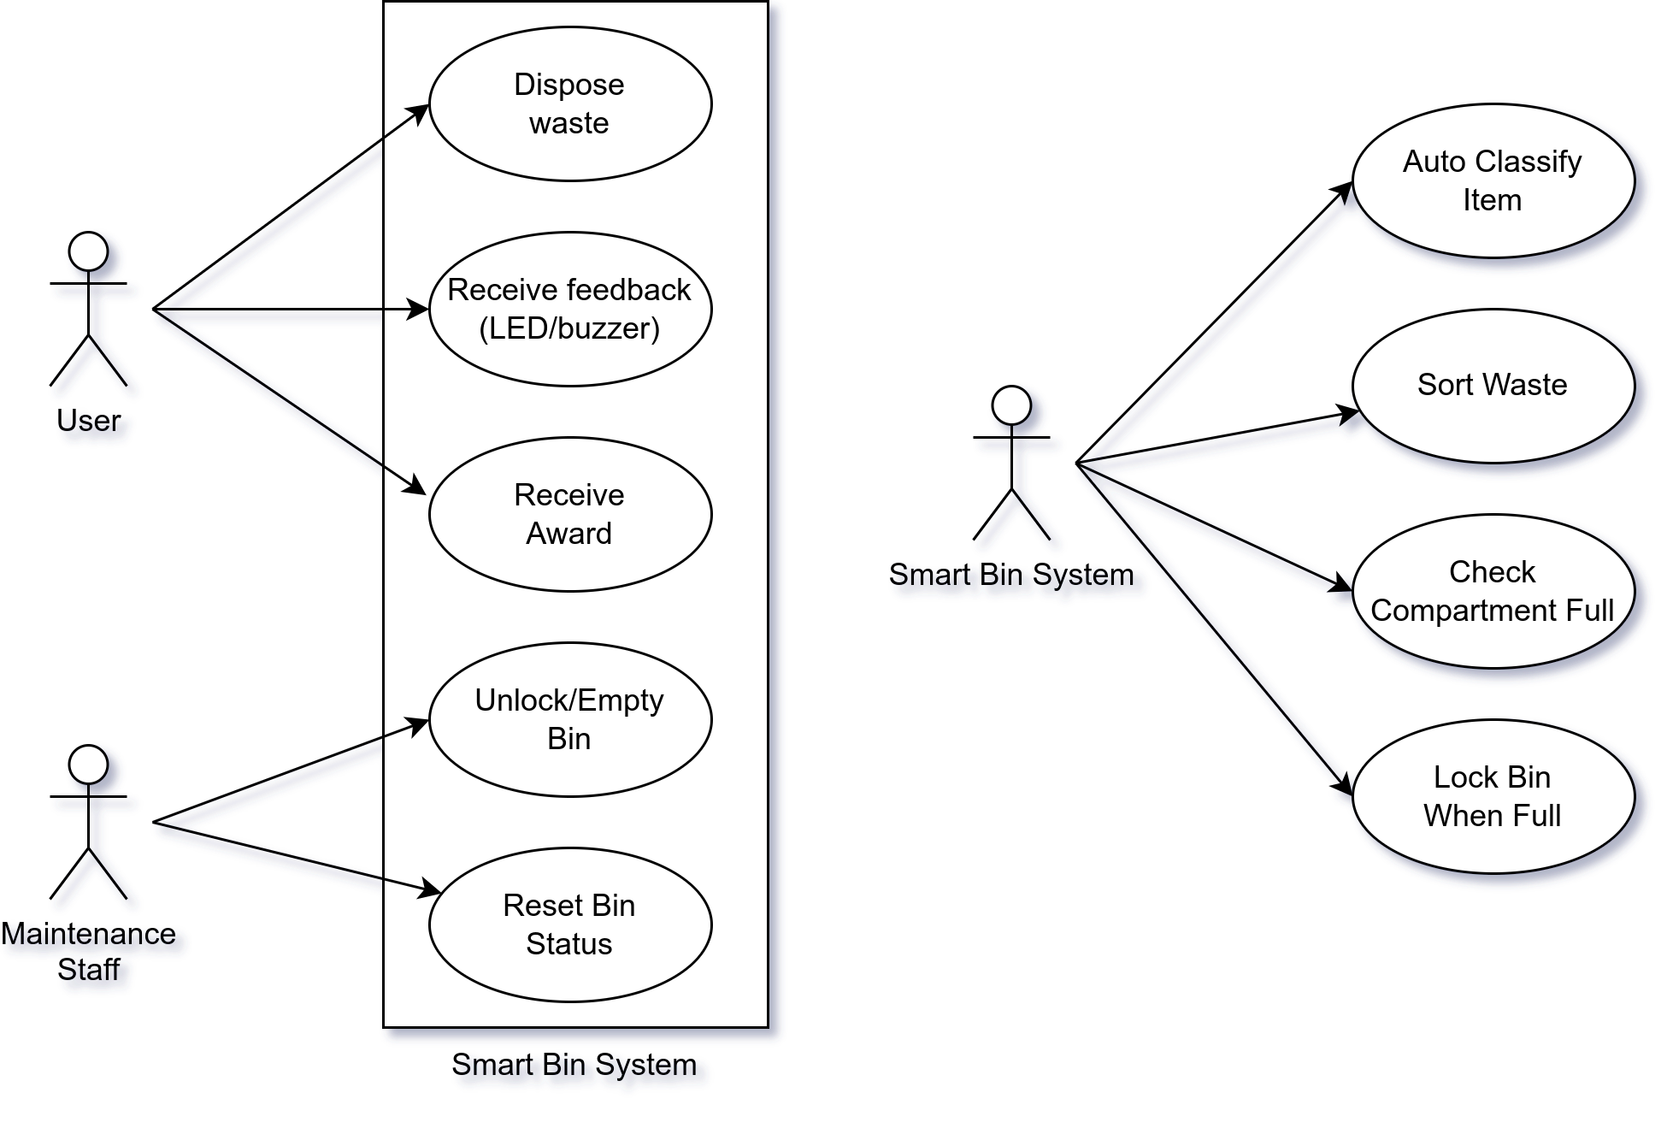

Figure 6: Smart Bin System use case diagram

### **3.5.2 System Flowchart**

This flowchart outlines the overall operation of the smart bin system, from input detection to classification, sorting, and reward dispensing.

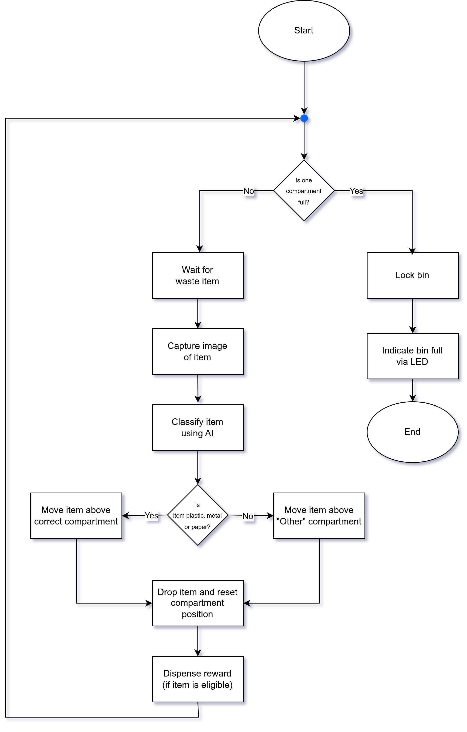

Figure 7: Smart Bin flow chart diagram

### **3.5.3 System Components and Interactions**

The system comprises the following key modules:

* Camera Module – Captures image of the object placed in the bin.
* Microcontroller – Acts as the system’s central control unit, running classification models and actuating motors based on decisions.
* AI Model (YOLOv5) – Classifies the object into one of the supported waste types: plastic, metal, or paper.
* Servo Motors – Control bin locking, platform rotation, and coin dispensing mechanisms.
* Ultrasonic Sensor – Detects whether a compartment is full.
* LEDs and Buzzer – Provide user feedback.
* Power Supply (Power Bank) – Portable power for all components.

The interaction between these modules is managed through firmware that runs on the microcontroller. Logic branches are designed to prevent operation when the bin is full and reward the user only if proper disposal is detected.

## 3.6. Conclusion

This chapter has presented the methodology adopted for the design and implementation of the AI-Driven Smart Bin system. It began by outlining the chosen development approach—Agile methodology—which supports the iterative nature of both hardware prototyping and AI model training. The chapter then detailed the information gathering process, including literature review, site observations, and user surveys, which collectively informed the system's requirements and design decisions.

User and system requirements were carefully specified to guide the integration of mechanical, electronic, and AI components. The system analysis section utilized structured analysis techniques and diagrammatic tools to break down the functional flow of the smart bin, including use case and process interactions.

Together, these activities have laid a solid foundation for the development and implementation phase, ensuring that the smart bin will be both technically feasible and aligned with real-world usage needs

# Chapter 4: System Design

## 4.1. Introduction

This chapter presents the design process and engineering decisions behind the development of the Smart Bin: AI-Driven Waste Sorting System. It outlines the system architecture, key hardware and software modules, and how the various components interact to achieve autonomous waste classification, sorting, and user engagement through a reward mechanism.

Throughout the development of this project, a number of design decisions were made, each informed by technical feasibility, resource availability, and real-world usage considerations. For example, the choice to classify only plastic, paper, and metal waste was guided by early observations of common disposal habits in public environments, as well as survey feedback from potential users. Similarly, the decision to implement on-device waste classification using a lightweight model such as YOLO was influenced by the system’s embedded nature and power constraints.

Trade-offs had to be made between accuracy and speed, hardware complexity and cost, and user experience and system autonomy. In several cases, iterative testing and prototyping guided the refinement of the design.

The sections that follow describe:

* The overall system architecture, including how hardware and software components are integrated.
* The breakdown of individual modules, such as the AI-based classification unit, actuation logic, and reward system.
* The design of the interfaces between hardware and software components.
* An overview of algorithms used for classification and control.
* Maintenance recommendations for long-term use and deployment in public spaces.

Additionally, this chapter provides a rationale for each major design decision, along with reflections on challenges encountered and how they were addressed. Once the survey period concludes, its findings will be incorporated to further validate or refine the system design and its targeted use environments.

## 4.2. System Analysis

The Smart Bin system was conceptualized to address a growing need for more intelligent and autonomous waste disposal solutions in public and semi-public spaces. Traditional bins often lead to mixed waste streams, low recycling efficiency, and limited user engagement in proper waste disposal practices. The core problem identified is the lack of an accessible, automated solution that can perform real-time waste classification and sorting, while simultaneously incentivizing users to participate in correct disposal behavior.

Based on the requirements specification and the information gathered through observation, literature review, and ongoing surveys, the system must fulfill the following high-level objectives:

* Automatically identify and classify commonly discarded waste items into plastic, aluminum (metal), or paper categories.
* Sort waste into the correct physical compartments without requiring manual intervention.
* Detect when a compartment is full and lock the system to prevent overfilling.
* Provide user feedback (via LED/buzzer) to indicate bin status.
* Optionally dispense a reward token to incentivize correct disposal.
* Operate autonomously and reliably on portable power, suitable for public environments.

These objectives must be achieved while ensuring:

* Low latency during classification and sorting (to prevent user frustration)
* High accuracy in detection (to ensure correct sorting and fair rewards)
* Physical safety and robustness for public deployment

The system also needs to accommodate future improvements, such as:

* Real-time usage logging and data analytics
* Wireless connectivity for remote monitoring
* Support for dynamic model updates (e.g. via SD card or OTA)

Thus, this analysis phase identifies what the system should do to solve the problem it was designed for — offering a blueprint for the design phase to determine how these needs will be technically fulfilled.

## 4.3. Context Model

The context model defines the boundaries between the Smart Bin system and its external environment. It identifies all the external entities that interact with the system and the nature of data or control flows exchanged with them.

At the center of the model is the Smart Bin System, which is influenced by multiple external entities. These include the User, who disposes of waste and receives feedback or rewards; the Maintenance Staff, who empties compartments and resets the bin; the Power Source, which provides energy for all operations; and the physical environment, particularly lighting conditions that may affect the performance of the vision system. Additionally, survey participants and datasets form part of the contextual environment during development and training of the AI model.

These interactions are visually represented in the system’s context diagram, which forms the basis for identifying system boundaries, responsibilities, and external interfaces during design.

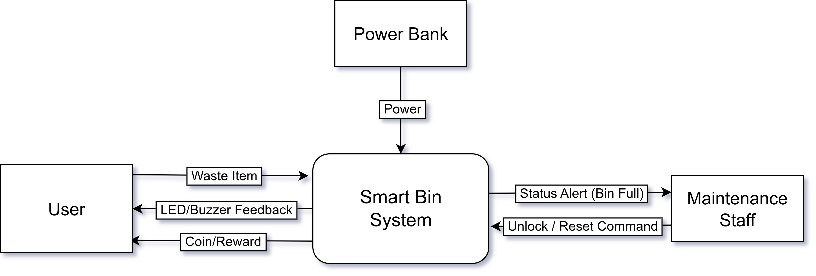

Figure 8: Smart Bin context diagram

## 4.4. Design Methods

### 4.4.1. Architectural Design

The architectural design of the Smart Bin System outlines the high-level structure of both the hardware and software subsystems, and how they interact to meet the functional and non-functional requirements. The architecture is designed for modularity, allowing each component to handle a specific responsibility within the overall system workflow.

#### Hardware Architecture

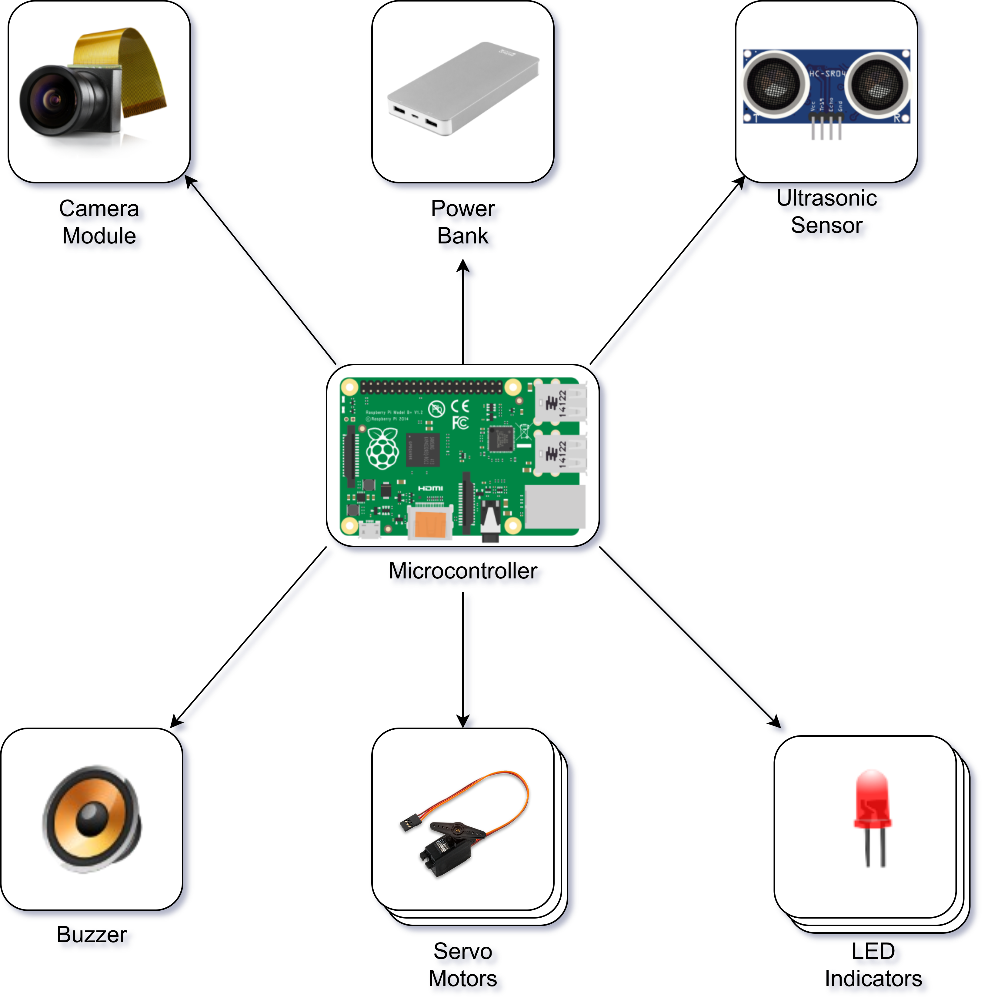

Figure 9: Smart Bin Architectural Design Diagram

* Power Bank: Portable power source to supply to all hardware components
* Microcontroller: Core processing unit for input/output control and integration logic
* Camera Module: Captures images of incoming waste for classification
* Servo Motor 1: Rotates platform to align the correct compartment beneath the drop point
* Servo Motor 2: Controls the lid opening/closing and drop release mechanism
* Servo Motor 3: Activates coin dispenser for reward when recyclable material is detected
* LED Indicator: Provides visual feedback (e.g., bin full, item accepted, error state)
* Speaker/Buzzer: Emits sound for alerts (e.g., successful drop, bin full, invalid item)

#### Software Architecture

The software component is structured into modules:

* **Image Capture Module** – interfaces with the camera to obtain images
* **AI Classification Module** – runs a YOLO-based model to classify the object into plastic, paper, or metal
* **Control Logic Module** – interprets classification results and manages mechanical operations (rotation, dropping, locking)
* **Feedback Module** – activates LEDs and buzzer signals
* **Fullness Monitoring Module** – reads from the ultrasonic sensor and determines whether to lock input
* **Reward Module** – controls coin dispensing logic

This modular architecture ensures clear separation of concerns and supports future scalability, such as adding data logging, wireless connectivity, or remote monitoring features.

#### System Integration

The microcontroller acts as the central processing and coordination unit, interfacing with sensors and actuators in real time. The entire system operates offline and autonomously, powered by a portable power source. The architecture has been designed to meet requirements for speed, accuracy, portability, and safety in public environments.

### 4.4.2. Detailed Design

The detailed design phase breaks down the Smart Bin System into individual functional modules and describes the behavior, logic, and interfaces of each module. The system follows a modular approach to ensure separation of concerns, ease of testing, and scalability. Each module is responsible for a specific function within the waste classification, sorting, and reward workflow. The design methodology used is Structured Analysis and Design (SAD), and system logic is further expressed through a Data Flow Diagram and pseudocode.

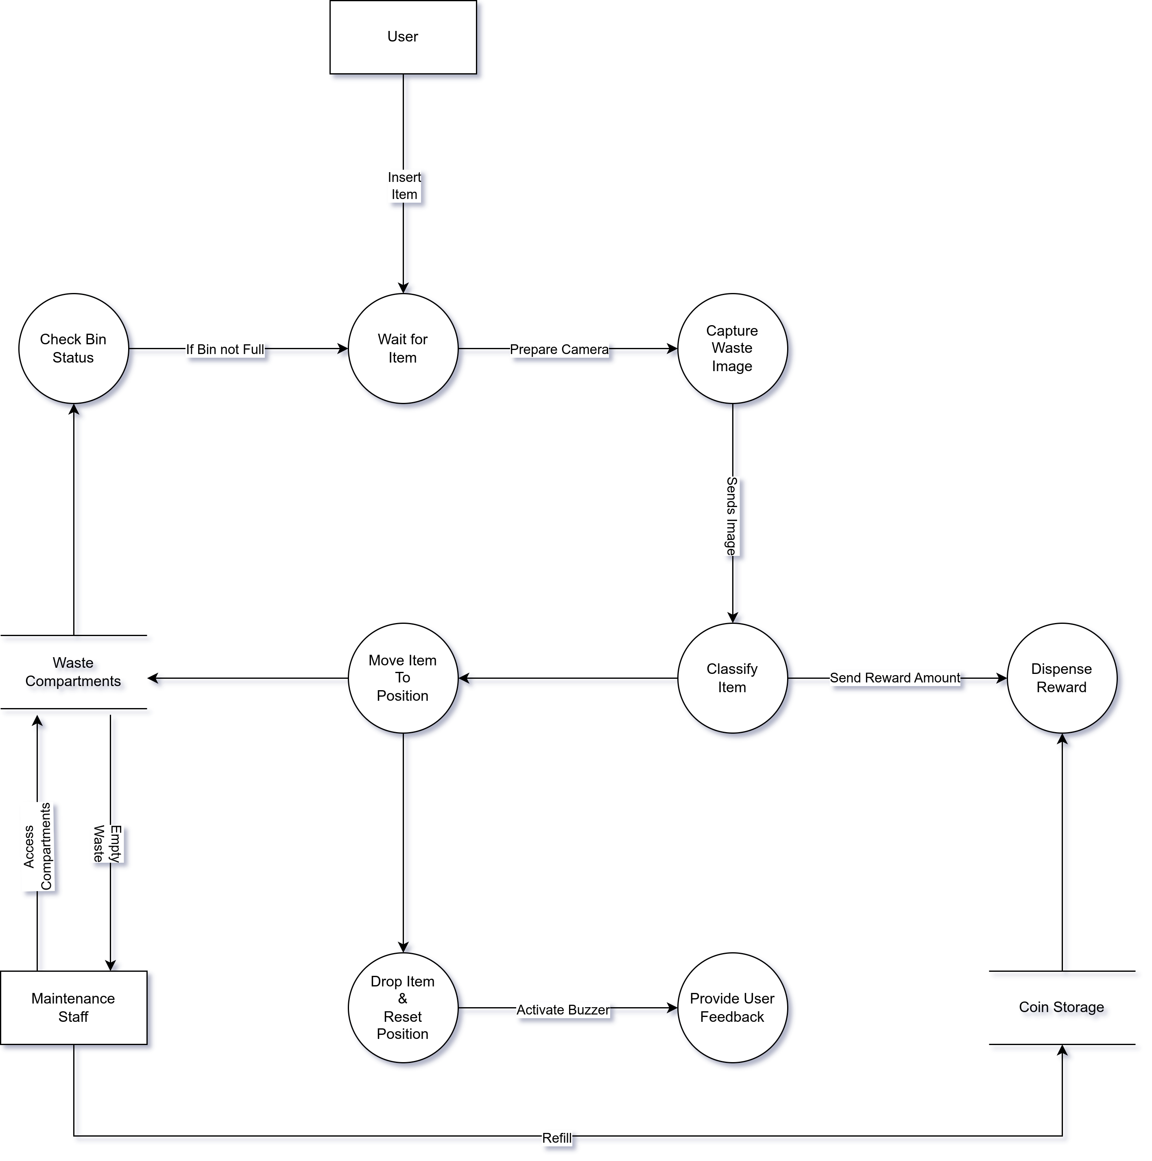

Figure 10: Smart Bin Data Flow Diagram

1. **Image Capture Module**

Purpose: This module captures an image of the waste item once inserted by the user.

* Input: Trigger signal when bin lid is closed
* Output: Still image (frame) sent to classification module
* Interface: Camera module (e.g., ESP32-CAM or USB camera)
* Process:
* Wait for lid to close
* Capture high-resolution image
* Send image to AI classification module

1. **AI Classification Module**

Purpose: Performs object detection using a lightweight YOLOv5 model to identify the material type.

* Input: Image from camera
* Output: Waste class label (plastic, paper, metal) or unknown
* Process:
  + Preprocess the input image
  + Run inference using pre-trained YOLO model
  + Return the class with highest confidence
* Design Choice: YOLO was chosen for its speed, accuracy, and ability to run on low-resource devices with quantized weights.

Pseudocode (simplified):

|  |
| --- |
| def classify(image):  result = yolo_model.predict(image)  if result.confidence > threshold:  return result.label  return "misc" |

1. **Linear Motion Control Module**

Purpose: Moves the waste container horizontally (along a track or guide rail) to position it above the correct waste compartment (plastic, paper, or metal).

* Input: Waste class label from AI module
* Output: Positioning signal to a linear actuator or belt-driven motor
* Interface: Stepper motor or DC motor with position feedback (e.g., via limit switches or encoders)
* Process:
  + Map each class label to a fixed horizontal position:
    - Plastic → position A
    - Paper → position B
    - Metal → position C
    - Misc → position D
  + Activate the motor to translate the container horizontally until the correct position is reached
  + Optionally, use limit switches or sensor feedback to detect arrival at each position
  + Signal the dropping mechanism module to proceed with releasing the item

1. **Dropping Mechanism Module**

Purpose: Opens a trapdoor or gate to drop the waste item into the aligned compartment.

* Input: Confirmation that rotation is complete
* Output: Drop signal to servo
* Interface: Servo motor attached to gate
* Process:
  + Activate gate servo
  + Wait fixed time (e.g. 2 seconds)
  + Close gate

1. **Bin Status Module**

Purpose: Checks whether the compartment for the predicted class is full, using an ultrasonic sensor.

* Input: Class label
* Output: Boolean flag (full/not full)
* Interface: Ultrasonic sensor mounted above each compartment
* Process:
  + Trigger and read distance from sensor
  + Compare with pre-set threshold
  + If full, lock bin and activate error feedback

1. **Reward Module**

Purpose: Dispenses a coin/token if the item is correctly classified and dropped.

Condition: Only dispense reward for classified recyclable items (plastic, metal, or paper).

If the classification result is misc, the drop process still occurs, but no reward is dispensed.

* Input: Success flag from drop mechanism
* Output: Servo actuation to release a coin
* Interface: Servo motor on coin dispenser
* Process:
  + Trigger servo for brief release motion
  + Wait fixed duration
  + Reset dispenser

1. **User Feedback Module**

Purpose: Provides real-time feedback using LEDs and buzzer tones to guide the user.

* Input: System state (e.g., idle, processing, error, bin full)
* Output: Colored LED signal and/or buzzer tone
* Examples:
  + Green LED → Ready
  + Yellow LED → Processing
  + Red LED or buzzer → Bin full / item unrecognized
  + Interface: GPIO lines to RGB LED and piezo buzzer

1. **System Coordination and Control Logic**

Purpose: Ensures the correct sequence of actions from start to finish.

Sequence:

1. Wait for item insertion (lid closes)
2. Capture image
3. Run classification
4. Check compartment status
5. If valid and not full:
   * Translate container to correct position
   * Drop item
   * Dispense reward
6. If classified as misc:
   * Move to miscellaneous compartment
   * Drop item
   * No reward dispensed
7. If classified item’s bin is full:
   * Lock bin and trigger full-bin feedback

### 4.4.3. Physical Design

The physical design of the Smart Bin system outlines how users interact with the device, how internal components are arranged, and how data and items move throughout the system. It focuses on input and output design, mechanical layout, and real-world usability in public or commercial settings.

#### **a) User Interaction**

Users interact with the system by placing a waste item into the input container located at the top of the bin. Once the item is inserted and the lid is closed, the bin temporarily locks to prevent interference during processing. After classification and sorting are complete, the bin automatically reopens, and — if applicable — dispenses a coin as a reward for proper disposal. The system uses LED indicators and/or a buzzer to inform the user of current status (e.g., idle, processing, full).

#### **b) Mechanical Layout**

Internally, the bin is divided into four compartments: plastic, paper, metal, and miscellaneous. The top container holding the waste item is mounted on a linearly translating platform (e.g., a belt or guide rail) controlled by a motor. After classification, the platform slides horizontally to align the container with the correct compartment. A servo-driven trapdoor beneath the container then opens, allowing the item to drop.

The compartments may each have a dedicated ultrasonic sensor to detect fullness. When a compartment is full, the system prevents further drops into that section and alerts maintenance staff.

#### **c) Data and Control Flow**

The camera module captures the image, which is classified by an onboard AI model. The result determines which compartment to move to. After verifying that the target compartment is not full, the bin executes the drop and optionally dispenses a coin. If the item is unrecognized, it is directed to the miscellaneous compartment and no reward is given.

#### **d) Output and Feedback**

Visual and auditory feedback is provided to users at each stage of the interaction:

* Green LED: Idle/Ready
* Yellow LED: Processing
* Red LED or buzzer: Full bin / error
* Coin slot and dispenser: Rewards for valid items

#### **e) 3D Design**

The physical structure and component layout are represented in a 3D model designed using FreeCAD. The model includes:

* Waste input port
* Translating container rail
* Internal compartments
* Servos and sensors
* Coin dispenser mechanism

*Figure 4.4.3.1 shows the 3D model of the Smart Bin, illustrating the internal layout and component placement.*

The design prioritizes portability, mechanical stability, and public safety, with all moving parts enclosed and accessible only for maintenance.

## 4.5. Conclusion

This chapter has detailed the overall design and architectural framework of the AI-Driven Smart Bin system. It began with the selection of a modular, structured approach for both hardware and software design, guided by the Structured Analysis and Design (SAD) methodology.

The design was broken down into architectural, detailed, and physical layers. At the architectural level, the high-level structure and hardware-software interaction were defined. The detailed design outlined the internal modules — such as image capture, classification, sorting logic, reward dispensing, and user feedback — while the physical design emphasized real-world interaction, internal layout, and 3D structural representation.

Furthermore, a comprehensive Data Flow Diagram (DFD) was developed to visually communicate the movement of data throughout the system, highlighting the interactions between the user, maintenance staff, control logic, and data stores. This structured breakdown provides a foundation for the implementation phase, ensuring all critical functions are addressed and logically connected.

The design also reflects the project's scalability, safety, and sustainability goals — providing a blueprint not only for prototyping but also for future iterations or enhancements.

# Chapter 5: Implementation

## 5.1 Introduction

Implementation refers to the practical realization of the Smart Bin system, transitioning the design specifications into a working prototype. This chapter outlines the hardware and software integration, explains how the ESP32-CAM, multiplexer, motors, and sensors are orchestrated to deliver functionality, and details the algorithms used for object classification and control. It also includes aspects of project management such as risk mitigation, configuration management, and system cutover considerations. The aim is to demonstrate how the theoretical design has been transformed into a functional, deployable solution.

## 5.2 System Implementation

### 5.2.1 Hardware Implementation

The system is built around the ESP32-CAM microcontroller, chosen for its low cost, integrated Wi-Fi capabilities, and onboard camera support. To manage the multiple motors and peripherals despite limited GPIO pins, a multiplexer is used, enabling sequential control of the devices.

The major hardware components include:

* ESP32-CAM: Central controller handling image acquisition, classification, and peripheral control.
* Motors (4 total):
* Lid motor – opens and closes the bin lid.
* Dropper motor – releases items from the temporary holding box.
* Sliding motor – moves the temporary box horizontally to align with the correct storage bin.
* Coin dispenser motor – provides incentives to users after correct disposal.
* Ultrasonic sensor: Detects the presence of a trash item inside the temporary holding box.
* Camera module (integrated with ESP32-CAM): Captures an image of the trash item for classification.
* LEDs: Provide system feedback (e.g., processing, error, ready states).

📌 Diagram 5.1: Block diagram of hardware components showing the ESP32-CAM connected to the multiplexer, which branches to the four motors and LEDs. The ultrasonic sensor and camera connect directly to the ESP32-CAM.

### 5.2.2 Software Implementation

The software stack is designed for efficiency given the ESP32-CAM’s limited resources. The key elements are:

* Embedded firmware written in Arduino C++ for:
* Controlling motors and LEDs through the multiplexer.
* Capturing images using the ESP32-CAM.
* Running inference with a TensorFlow Lite Micro (TFLite) classification model stored in flash memory.
* Executing the control algorithm (detect item → classify → move box → drop item → reset).
* Classification model: A lightweight neural network trained on three primary categories (paper, metal, glass) and one miscellaneous category. The model is quantized to run efficiently on the ESP32-CAM.

Control algorithm:

* Wait for ultrasonic sensor to detect presence.
* Capture image and run classification.
* Identify predicted category.
* Move the sliding box until aligned with the target bin.
* Trigger dropper motor to release item.
* Reset all components to idle positions.
* Activate coin dispenser motor if required.

### 5.2.3 Algorithm and Logic

* The system is governed by simple rule-based logic:
* If ultrasonic sensor = triggered, then capture image.
* If classification result = Paper, move to paper bin, drop item.
* Else if = Metal, move to metal bin, drop item.
* Else if = Glass, move to glass bin, drop item.
* Else, assign to miscellaneous bin.
* Optional feedback includes toggling LEDs during different stages:
* Green = system ready.
* Blue = processing/classifying.
* Red = error state.

## 5.3 Coding

The implementation relies on modular Arduino C++ code, divided into separate modules for:

* Motor control
* Ultrasonic sensor measurement
* LED control
* Camera capture and classification

## 5.4 Results

The implementation produced a functional prototype capable of autonomously detecting, classifying, and sorting waste items. The system successfully demonstrated the integration of sensors, motors, and machine learning classification on constrained hardware.

Observed system behaviors include:

* The ultrasonic sensor reliably detects the presence of an item in the temporary holding box.
* The ESP32-CAM captures images and runs the TensorFlow Lite Micro model, producing a classification among four categories: paper, metal, glass, miscellaneous.
* The sliding motor moves the holding box horizontally to the correct bin location.
* The dropper motor releases the item accurately into the designated bin.
* The lid motor operates automatically to allow items to be placed and then closes the bin.
* The coin dispenser motor activates correctly after successful disposal, providing a reward mechanism.
* LED indicators show the system state: ready, processing, or error.

📌 Figure 5.4: Photograph of the assembled Smart Bin prototype.

📌 Figure 5.5: Screenshot of serial output showing classification confidence values.

📌 Figure 5.6: Image sequence demonstrating the trash disposal process (detection → classification → movement → release).

The results confirm that the Smart Bin meets its functional requirements, although optimization of classification accuracy depends on dataset quality and lighting conditions.

## 5.5 Conclusion

The implementation phase has transformed the Smart Bin from a conceptual design into a working prototype. By combining computer vision, embedded machine learning, and electromechanical actuation, the system demonstrates how waste sorting can be automated efficiently using affordable components.

Key achievements include:

* Successful deployment of a quantized classification model on the ESP32-CAM.
* Integration of four motors and peripheral devices via a multiplexer, overcoming GPIO limitations.
* Reliable detection and sorting of items through a well-structured control algorithm.
* Inclusion of a coin dispenser incentive mechanism, enhancing system usability.

This chapter validates that the Smart Bin’s design is practical, cost-effective, and implementable within real-world scenarios such as public spaces and campuses.

# Chapter 6: Testing and Results

## 6.1 Introduction

Testing is a critical stage of system development, intended to verify that the Smart Bin prototype functions according to specifications. The purpose of testing is to identify and correct faults, ensure that both hardware and software modules perform reliably, and evaluate whether the integrated system meets user expectations. This chapter describes the testing strategies used, presents the results obtained, and provides analysis of the system’s performance.

## 6.2 Test Plan

The testing was divided into several stages to ensure comprehensive validation:

1. Unit Testing – focused on individual hardware and software components, including motors, ultrasonic sensor, LEDs, ESP32-CAM, and classification code.
2. Integration Testing – verified interaction between subsystems such as sensor detection with camera capture, or classification with motor actuation.
3. System Testing – evaluated the Smart Bin as a whole, running the full sequence from trash detection to disposal and reward dispensing.
4. User Testing – although limited, a conceptual evaluation was conducted by simulating real-world use cases to assess usability.

## 6.3 Test Environment

Testing was performed indoors in laboratory conditions under varying lighting levels. Since lighting directly influences image quality and therefore classification accuracy, results were observed under both bright and dim environments. A Bluetooth connection to a laptop was used to run the classification model externally and send results back to the ESP32-CAM. This workaround improved performance speed during testing.

## 6.4 Test Cases and Results

### 6.4.1 Unit Testing

* Motors: Each of the four motors was tested individually to verify motion and direction. Results showed consistent operation with negligible lag.
* Ultrasonic Sensor: Successfully detected items placed in the temporary holding box within a range of 2–15 cm. Accuracy decreased for smaller or irregularly shaped items.
* LEDs: All indicator LEDs functioned as expected, displaying system readiness, processing states, and error alerts.
* Camera Module: Captured clear grayscale images in bright light; noise increased under dim light.

Result: All unit tests passed, although environmental factors affected sensor and camera performance.

### 6.4.2 Integration Testing

* Ultrasonic + Camera: Item detection reliably triggered image capture.
* Camera + Classification: Images captured were successfully transmitted via Bluetooth to a laptop for model inference, then results returned to the ESP32-CAM.
* Classification + Motor Control: Motor actuation responded correctly to classification outputs, moving the temporary holding box to the assigned bin.

Result: Integration tests passed, but reliance on Bluetooth increased complexity.

### 6.4.3 System Testing

A complete cycle was tested:

1. Lid opened.
2. Item detected by ultrasonic sensor.
3. Camera captured image and transmitted to laptop.
4. Model classified item (paper, metal, glass, misc).
5. Sliding motor aligned holding box with correct bin.
6. Dropper motor released item.
7. Coin dispenser activated where applicable.
8. System reset.

Result:

* Success rate of end-to-end cycle: 85%.
* Failures occurred due to misclassification (approx. 30% error rate), occasional delays in Bluetooth communication, and difficulty in detection of irregular objects.

### 6.4.4 User Testing

Although not formally conducted, simulated user trials were carried out. When operated as intended, the system was intuitive, with LEDs providing useful feedback. Users were expected to place items individually, as multiple simultaneous items confused the detection and classification process.

Result: Indicated general usability but highlighted the need for more robust instructions for end users.

## 6.5 Analysis

Testing confirmed that the Smart Bin prototype is functional and demonstrates the feasibility of automated waste classification. However, several challenges were observed:

* Classification Accuracy: At approximately 70%, the model requires improvement through larger datasets and optimized training.
* Environmental Sensitivity: Lighting conditions affected both image clarity and classification accuracy.
* Hardware Limitations: The ESP32-CAM alone was insufficient for real-time classification; external offloading via Bluetooth improved speed but reduced self-containment.
* System Robustness: Motors and sensors were reliable, though occasional misalignment of the sliding box occurred due to mechanical tolerances.

Despite these issues, the system consistently demonstrated the core process of detection, classification, and disposal.

## 6.6 Conclusion

The testing phase validated that the Smart Bin meets its basic requirements. It successfully integrates hardware and software to detect waste items, classify them, and perform automated disposal with incentive dispensing. The system’s main limitation lies in classification accuracy and reliance on external processing, but the prototype establishes a strong foundation for future optimization.